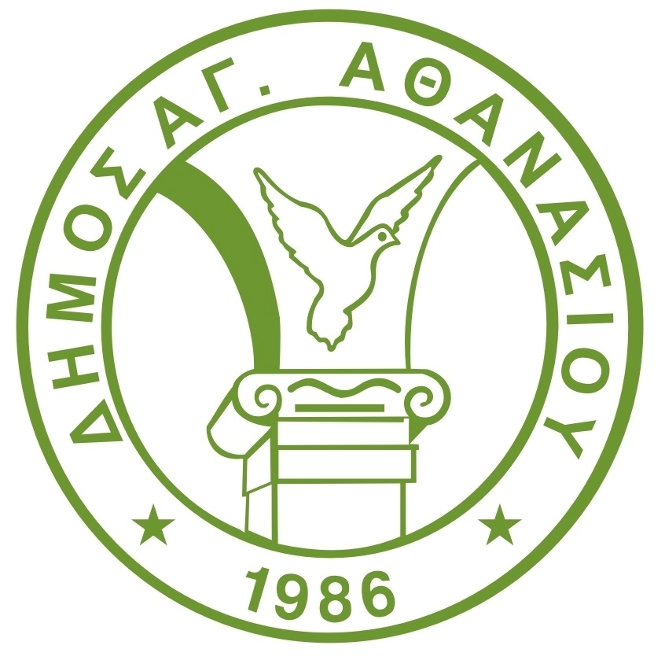
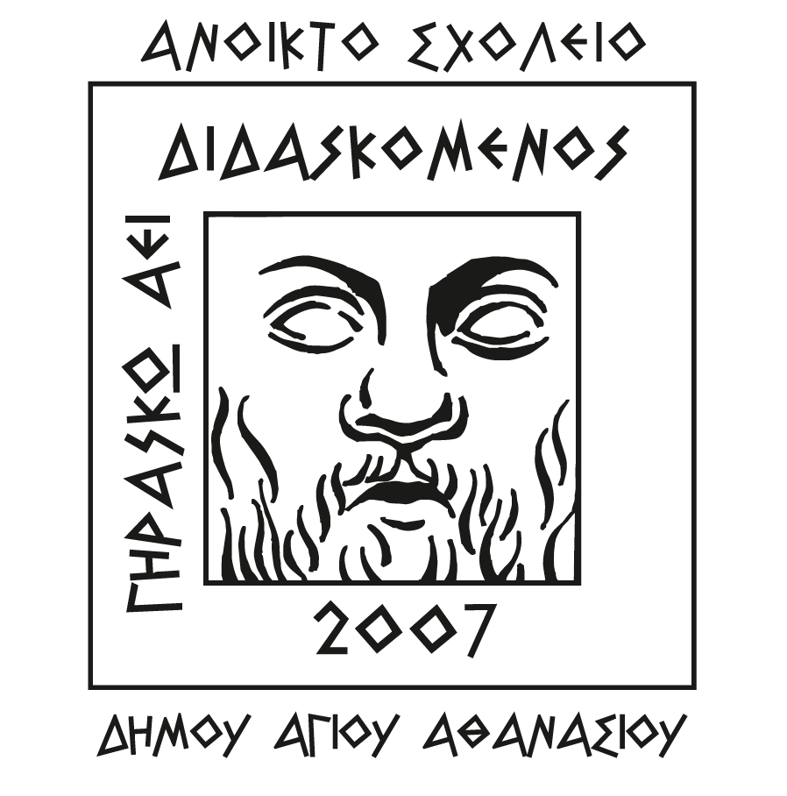
OPEN SCHOOL - AGIOS ATHANASIOS MUNICIPALITY
NEW COURSES FOR GREEK LESSONS

APPLICATION FORM

Name: ................................................. Native Language: ........................ Nationality: ........................ Age: .......

Address: .....................................................…….Telephone: ................... E-mail: ................................................

Gender: ◻Female ◻Male

 | Primary Education | Secondary Education | High School | College/University
Educational Background

Greek Language Level
 | Very Good (B2) | Good (B1) | Poor (A2) | Not at All (A1)
Reading
Writing
Listening
Speaking

COURSE FEES: 130 EURO for levels A1 and A2 / 160 EURO for levels B1 and B2
(*if the minimum number of 15 persons is not reached, then the participants will cover the difference on the charge themselves)

Preferred Courses **TO CREATE A GROUP WITH AT LEAST 15 PERSONS

◻ 2 Weekdays - Morning
◻ 2 Weekdays – Afternoon / Evening

If you are interested, please complete the APPLICATION FORM and send it scanned via email at anoikto.sxoleio.ag@cytanet.com.cy or via viber/whatsapp at 97717187.

For more information or clarifications please call at 97717187.

SIGNATURE: ……………………………………………. Date: ...........................

